Flavour Fusion: AI-Driven Recipe Blogging Studio

1. INTRODUCTION
1.1 Project Overview
Flavour Fusion is an AI-powered web application developed to generate structured and customized recipe blog content automatically. The system uses advanced Large Language Models (LLMs) to create engaging, detailed, and well-formatted recipe articles based on user input.
The application is built using Streamlit for the frontend and Google Gemini 2.5 Flash model for backend AI processing. Users can enter a recipe topic, select cuisine type, specify word count, and instantly generate professional-quality recipe blogs. The system also maintains session-based history and allows downloading generated content.
1.2 Purpose
The main purpose of this project is to:
• Assist food bloggers in generating recipe content instantly
• Reduce manual writing effort
• Improve productivity in content creation
• Provide structured and engaging blog articles
• Demonstrate practical implementation of Generative AI
• Support academic and professional learning in AI applications
Team ID : LTVIP2026TMIDS24867
Team Members :
- A Charishma
- Abdul Gafoor
- Alaparthi Yaswanth Kiran
- Anudeep Avula
2. IDEATION PHASE
2.1 Problem Statement
Content creation for recipe blogs requires time, creativity, and structured formatting. Many food bloggers and content creators struggle to generate high-quality, SEO-friendly, and engaging content consistently.
Manual writing is time-consuming and repetitive. There is a need for an automated system that can generate structured recipe blog content quickly, accurately, and efficiently using Artificial Intelligence.
2.2 Empathy Map Canvas
Category | Description
Thinks | How to write engaging recipe blogs faster?
Feels | Stressed due to content deadlines
Says | Writing blogs takes too much time
Does | Searches for recipe formats online
Pain | Writer’s block, low productivity
Gain | Instant structured content
2.3 Brainstorming
During brainstorming, various ideas were discussed:
- Manual recipe template generator
- SEO-based blog assistant
- AI chatbot for cooking help
- AI-based recipe blog generator
- Automated content publishing system
The final idea selected was an AI-based Recipe Blog Generation Platform.
3. REQUIREMENT ANALYSIS
3.1 Customer Journey Map
User opens application
Enters recipe topic
Selects cuisine type
Chooses word count
Clicks “Generate Recipe”
Receives AI-generated blog
Downloads recipe
3.2 Solution Requirement
Hardware Requirements
• Computer / Laptop
• Internet connection
Software Requirements
• Python 3.10+
• Streamlit
• Google Generative AI (Gemini API)
• python-dotenv
• Requests Library
3.3 Data Flow Diagram
User Input
Prompt Construction
Gemini API Request
AI Response
Display Output
Session Storage
Download File
3.4 Technology Stack
Component | Technology
Frontend | Streamlit
Backend | Python
AI Model | Google Gemini 1.5 Flash
Storage | Streamlit Session State
API | Google Generative AI API
Environment | dotenv
4. PROJECT DESIGN
4.1 Problem Solution Fit
The proposed solution provides an automated and intelligent method of generating recipe blog content. It eliminates manual effort and improves productivity by using advanced Generative AI models.
4.2 Proposed Solution
The system allows users to:
⎫ Enter recipe topic
⎫ Select cuisine type
⎫ Choose word count
⎫ Generate AI-based recipe blog
⎫ View structured output
⎫ Download generated content
⎫ Store session history
This creates a complete AI-powered content creation workflow.
4.3 Solution Architecture

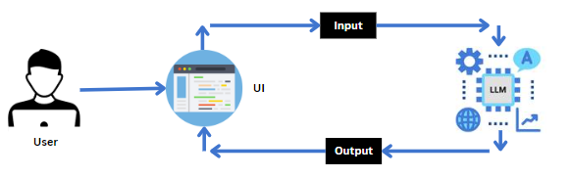

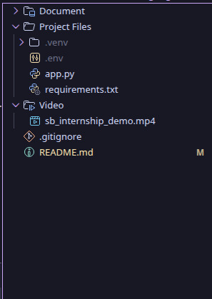
5. PROJECT PLANNING & SCHEDULING
5.1 Project Planning
Phase | Duration
Requirement Analysis | 1 Week
Design | 1 Week
Development | 2 Weeks
Testing | 1 Week
Deployment | 1 Week
Documentation | 1 Week
6. FUNCTIONAL AND PERFORMANCE TESTING
6.1 Performance Testing
Response time: 5–20 seconds (depending on word count)
API validation: Successful
Session storage: Working properly
Download functionality: Working
Concurrent users: Limited (Local deployment)
Testing confirmed stable performance and accurate content generation.
7. RESULTS
Home Screen:
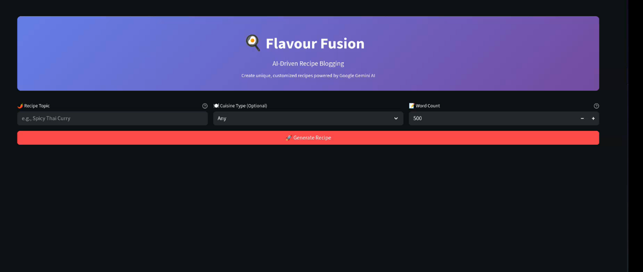
Recipe Generation Output:
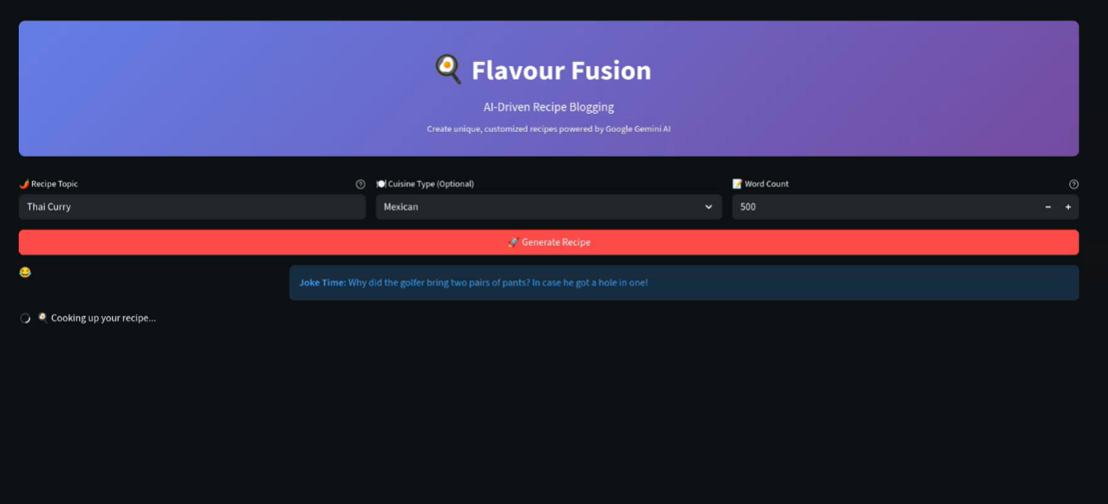
Input Form Interface:
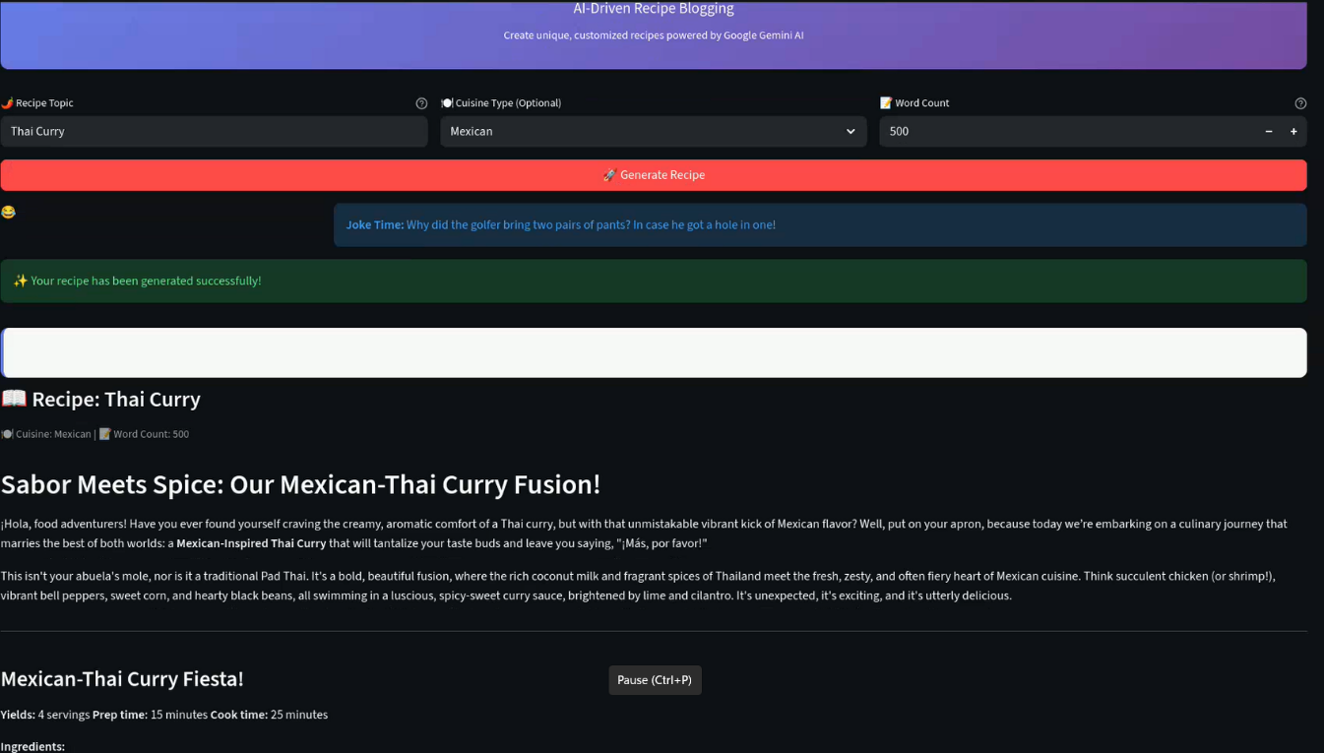

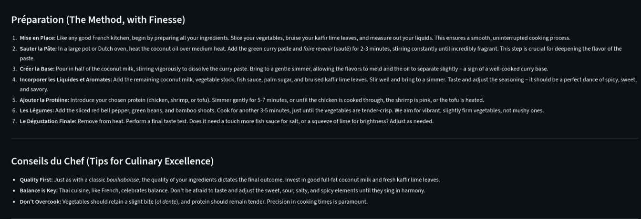
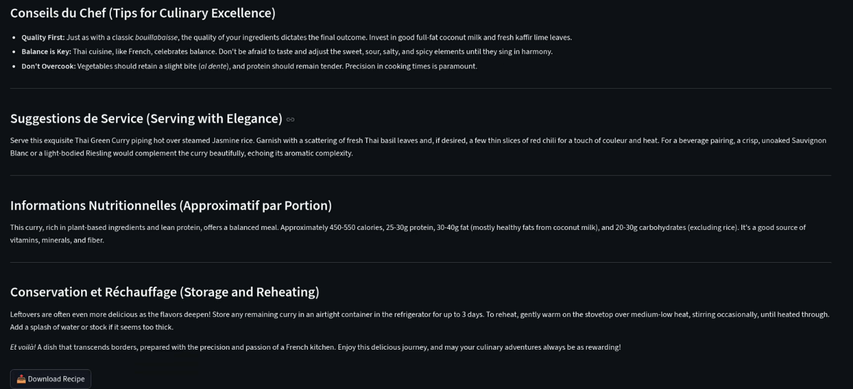
8. ADVANTAGES & DISADVANTAGES
Advantages
• Instant blog generation
• Easy to use interface
• Customizable word count
• AI-powered content
• Download option
• Session history tracking
Disadvantages
• Requires internet connection
• Depends on API availability
• Limited free API usage
• No built-in SEO optimization
9. CONCLUSION
The Flavour Fusion project successfully demonstrates the practical implementation of Generative AI in content creation. By integrating Google Gemini with a Streamlit-based interface, the system provides an intelligent and automated recipe blogging solution.
It reduces manual effort, improves productivity, and showcases real-world AI integration for web applications.

10. FUTURE SCOPE
Future enhancements include:
ϖ Multi-user login system
ϖ Cloud database integration
ϖ SEO optimization module
ϖ Blog publishing integration
ϖ Image generation for recipes
ϖ Mobile application version
ϖ Voice-based recipe input
11. APPENDIX
Software Libraries
• Streamlit
• python-dotenv
• Google Generative AI
• Requests
API
• Google Gemini API
References
• Google AI Documentation
• Streamlit Documentation
• Python Documentation
GitHub Link:
https://github.com/yash5800/internship_smartBridge_long.git

